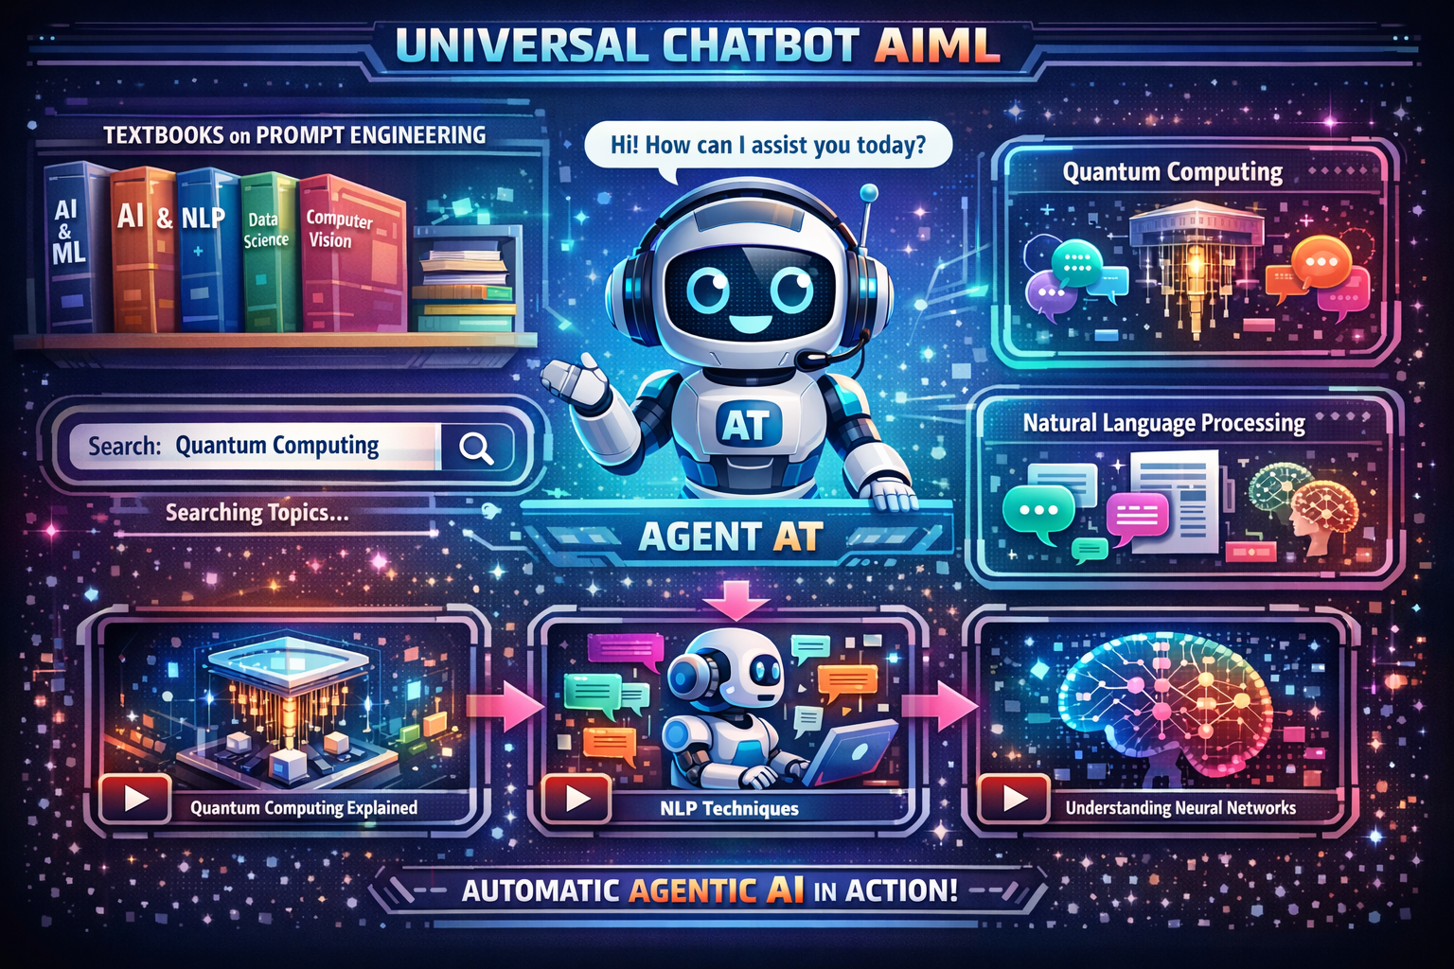Simple Explanation of the Diagram

1. Universal Chatbot (AIML)
- The center robot (Agent AT) represents a universal chatbot built using AIML and AI technologies.
- This chatbot is the main controller that understands user questions and responds intelligently.

2. Educational Textbooks (Prompt Engineering)
- On the left side, you can see textbooks like:
  - AI & ML
  - NLP
  - Data Science
  - Computer Vision
- These books represent educational content, especially prompt engineering topics.
- The chatbot can access these textbooks digitally and use them to answer questions.

3. Search and Topic Selection
- There is a search bar (example: Quantum Computing).
- When a user types a topic:
  - The chatbot automatically searches inside the textbooks.
  - It finds relevant chapters and concepts.

4. Graphical & Video-Based Learning
- At the bottom section, you see video icons and visuals.
- This means:
  - Topics are explained using videos, diagrams, and animations.
  - Learning becomes easy and visual, not only text-based.

5. Intelligent Agent (Agent AT)
- Agent AT works as an automatic agentic AI:
  - Understands user requests
  - Searches textbooks
  - Selects topics
  - Converts them into graphical and video explanations
- All steps happen automatically and sequentially, without manual effort.

6. Multiple Subjects Support
- On the right side, examples like:
  - Quantum Computing
  - Natural Language Processing
- This shows the chatbot can handle multiple subjects in one system.

7. Single Template / Single Chatbot
- Everything works inside one single chatbot interface:
  - Search
  - Learning
  - Videos
  - Graphics
  - AI explanations
- No need for multiple apps or tools.
PROJECT DOCUMENTION
TITLE
Universal Educational chatbot using AI/ML with Agentic AI for visual Learning.
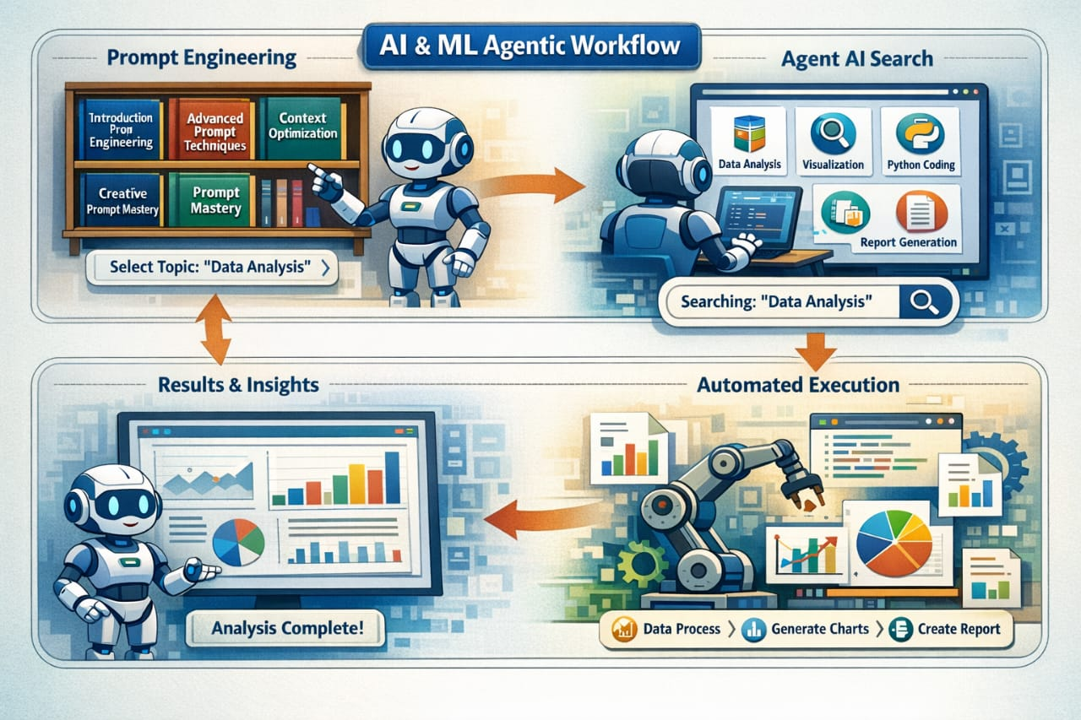.

1. Introduction
With the rapid growth of Artificial Intelligence in education, there is a strong need for intelligent systems that can provide interactive, visual, and automated learning experiences. Traditional learning methods rely heavily on static textbooks and manual searching, which can be time-consuming and less engaging.
This project focuses on the design and conceptual implementation of a Universal Educational Chatbot using AIML and Agentic AI, capable of searching educational textbooks related to Prompt Engineering and AI topics and delivering content in a graphical and video-based format through a single chatbot interface.

2. Problem Statement
Students and learners face the following challenges:
- Difficulty in searching topics across multiple textbooks.
- Lack of visual and video-based explanations.
- Absence of an automated system that follows learning steps sequentially.
- Need to switch between multiple platforms for text, video, and explanations.
Hence, a single intelligent chatbot system is required to solve all these issues.

3. Proposed Solution
The proposed solution is a Universal Chatbot powered by AIML and Agentic AI, named Agent AT, which:
- Stores and accesses educational textbooks.
- Allows topic-based searching.
- Automatically processes learning steps.
- Presents explanations using text, graphics, and videos.
- Works in a single unified interface.

4. System Architecture Overview
The system consists of the following main components:

4.1 Universal Chatbot (AIML-Based)
- Acts as the main user interaction interface.
- Uses AIML rules and AI logic to understand user queries.
- Responds with intelligent and relevant outputs.

4.2 Educational Textbook Repository
- Digital collection of textbooks related to:
  - Prompt Engineering
  - Artificial Intelligence
  - Machine Learning
  - Natural Language Processing
  - Data Science
  - Computer Vision
- Serves as the primary knowledge base.

4.3 Search and Topic Identification Module
- Accepts user input through a search bar.
- Searches for relevant topics within textbooks.
- Filters and selects appropriate learning material.

4.4 Agentic AI (Agent AT)
- Works as an autonomous intelligent agent.
- Executes tasks in a sequential and automatic manner:
  - Understand user query
  - Search textbooks
  - Identify topics
  - Select learning format
  - Present results

4.5 Visual and Video Learning Module
- Converts textual information into:
  - Graphical representations
  - Animations
  - Video explanations
- Enhances understanding and engagement.

5. Working Methodology
The system operates in the following sequence:
- User enters a topic in the chatbot (e.g., Quantum Computing).
- The chatbot processes the query using AIML rules.
- Agent AT searches the textbook repository.
- Relevant chapters and concepts are identified.
- The system automatically selects visual and video resources.
- The user receives explanations in an easy-to-understand graphical format.
This entire process happens automatically without manual intervention.

6. Features of the System
- Single chatbot interface
- Automatic topic searching
- Support for multiple AI-related subjects
- Visual and video-based explanations
- Intelligent agent-based workflow
- User-friendly learning experience

7. Advantages
- Reduces learning time
- Improves concept understanding
- Encourages interactive learning
- Eliminates the need for multiple learning platforms
- Suitable for beginners and advanced learners

8. Applications
- Educational institutions
- Online learning platforms
- AI and Prompt Engineering training programs
- Self-learning systems
- EdTech solutions

9. Future Enhancements
- Integration with real-time video platforms
- Voice-based interaction
- Multilingual support
- Performance-based learning recommendations
- Integration with Learning Management Systems (LMS)

10. Conclusion
The Universal Educational Chatbot using AIML and Agentic AI provides a comprehensive solution for modern digital learning. By combining textbooks, intelligent agents, and visual learning, the system ensures an efficient, engaging, and automated educational experience within a single template or chatbot environment.

Flow Chart Description

Universal Educational Chatbot Using AIML and Agentic AI

Flow of Operations (Step-by-Step)
- Start
  - The system initializes the Universal Chatbot (Agent AT).
- User Interaction
  - The user enters a query or topic (e.g., “Quantum Computing”) through the chatbot interface.
- Query Understanding (AIML Engine)
  - The AIML-based chatbot analyzes the user input.
  - It identifies intent, keywords, and subject domain.
- Agentic AI Activation (Agent AT)
  - Agent AT is triggered to handle the task autonomously.
  - It manages all steps sequentially.
- Search Educational Textbook Repository
  - The agent searches digital textbooks related to:
    - Prompt Engineering
    - AI, ML, NLP, Data Science, etc.
  - Relevant chapters and concepts are retrieved.
- Topic Filtering and Selection
  - The system filters the most appropriate content.
  - Subtopics are identified for explanation.
- Learning Format Decision
  - Agent AT decides the best presentation format:
    - Text
    - Graphics
    - Videos
    - Animations
- Visual & Video Content Generation
  - The selected topic is converted into:
    - Graphical explanations
    - Video-based learning modules
- Response Delivery
  - The chatbot displays the explanation to the user in an interactive and visual manner.
- End / Continue Interaction
  - The user may ask another question or continue learning.
  - The process repeats automatically.

Textual Flow Chart Representation
Start
↓
User enters topic
↓
AIML processes query
↓
Agent AT activated
↓
Search textbook repository
↓
Filter & select topic
↓
Choose learning format
↓
Generate visuals & videos
↓
Display results to user
↓
End / Next Query

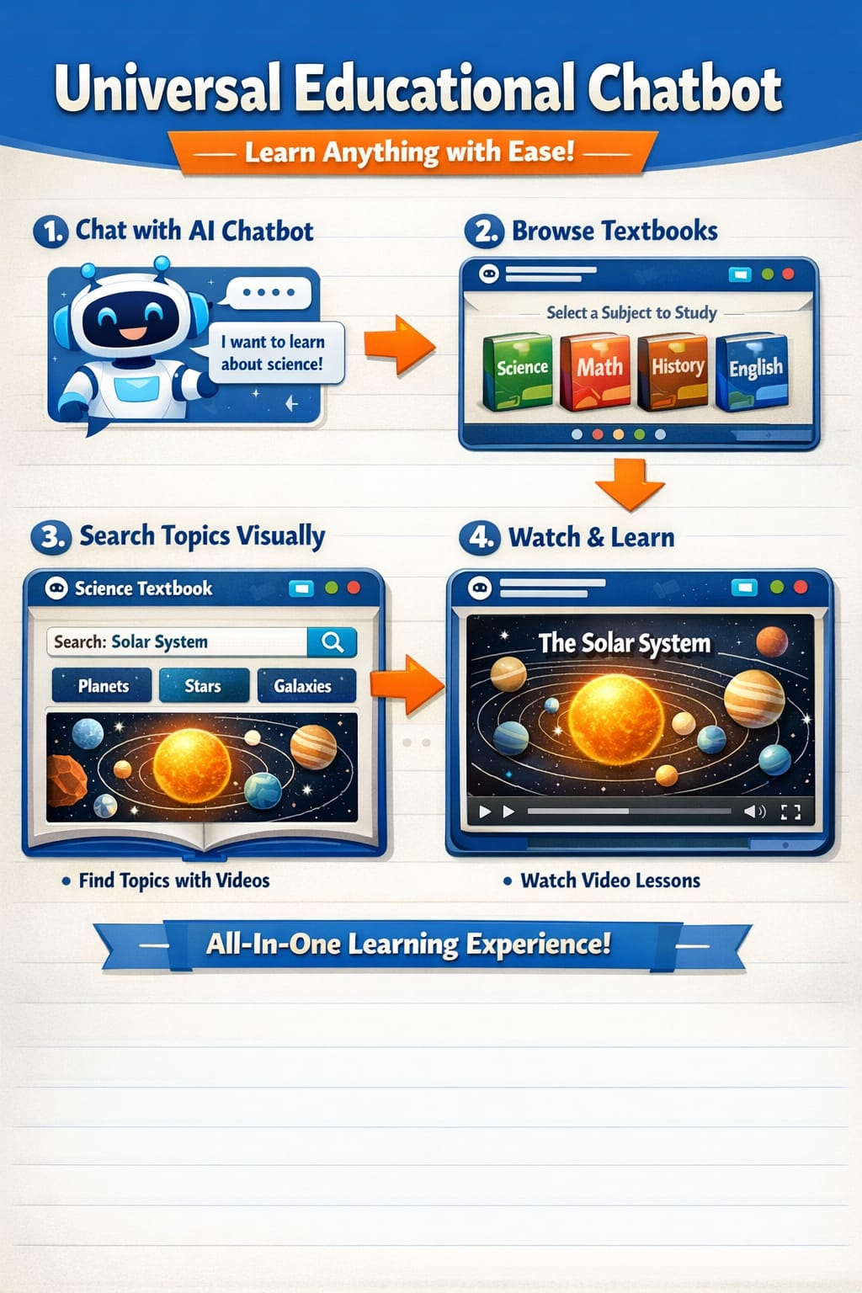System Architecture Description

Overview
The system architecture represents a single unified chatbot platform that integrates AIML, educational content, agentic AI, and visual learning modules to provide automated and interactive education.

Architecture Components

1. User Interface Layer
- Chatbot interface where users:
  - Enter queries
  - View text, graphics, and videos
- Acts as the front-end of the system.

2. AIML Chatbot Engine
- Processes user input using predefined AIML rules.
- Identifies:
  - User intent
  - Keywords
  - Subject category
- Acts as the communication bridge between user and system.

3. Agentic AI Controller (Agent AT)
- Core intelligent component of the system.
- Responsible for:
  - Task sequencing
  - Decision-making
  - Automation of learning flow
- Coordinates all backend modules.

4. Educational Textbook Repository
- Digital storage of textbooks and learning materials.
- Covers:
  - Prompt Engineering
  - AI, ML, NLP, Data Science
- Provides structured educational data.

5. Search and Topic Management Module
- Searches textbooks based on query.
- Extracts relevant chapters and topics.
- Ensures accurate content retrieval.

6. Visual & Video Learning Module
- Converts textual content into:
  - Graphs
  - Diagrams
  - Animations
  - Video explanations
- Enhances learner understanding and engagement.

7. Output & Presentation Layer
- Displays results in a single chatbot window.
- Ensures:
  - Clear explanations
  - Interactive learning experience
  - Seamless navigation

Architecture Flow (High-Level)
User
↓
Chatbot Interface
↓
AIML Engine
↓
Agent AT (Agentic AI)
↓
Textbook Repository
↓
Search & Topic Module
↓
Visual/Video Generator
↓
User Interface

Summary
This architecture ensures that:
- All learning processes occur within one chatbot
- The system operates automatically and sequentially
- Users receive visual, video-based, and textbook-backed explanations
- Agent AT intelligently manages the entire workflow

.

